Database management systems (DBMS)
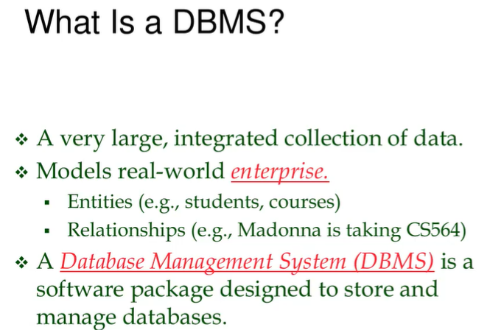
Database: collection of some data (!not just some data) data structured in some ways, aka it represents some real world system.

A graph is a representation of data (in the nodes) while the edges represent some connections between the data.

- Entity: something we care about in the system (students, courses). What is important and what we want to talk about.
- Relationship: connect entities and tell us how they are related (Madonna is taking Calculus I). It’s the “verb”.

- Database: just store data, it is passive
- DBMS: are the programs that act on the database

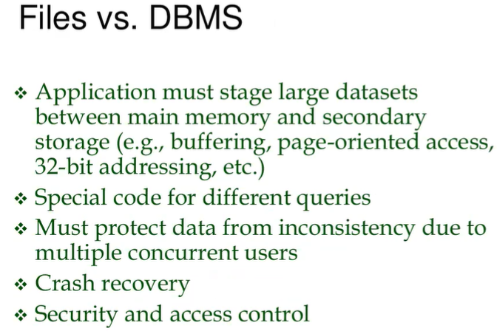
Why use DBMS to manage data and not a .csv file?
- if your data start growing ⟹ you need to deal with different issues (hard drive memory, speed). It is impossible to load all the data in a .csv file. DBMS have a buffering approach, not used data is not loaded
- Get some specific data ⟹ need to write a new function in Python. Every time you want something else you need to write a new function. In DBMS you have a specific language to deal with this

Depending on what you want DBMS can be a good choice
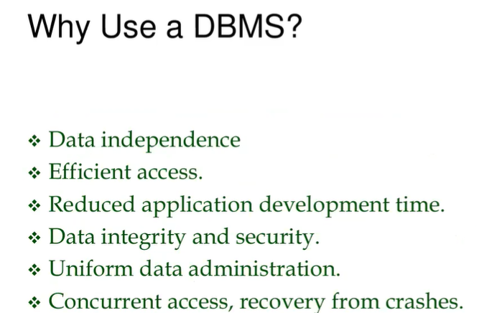
- Data independence: give you a way to query your data independently on where the data (entities or relations) are. DBMS do not care where the data is
- Efficient access: a lot of strategies on how to handle data is already done by people before us
- Data integrity and security: can add some constraint (a student cannot follow two courses at the same time)

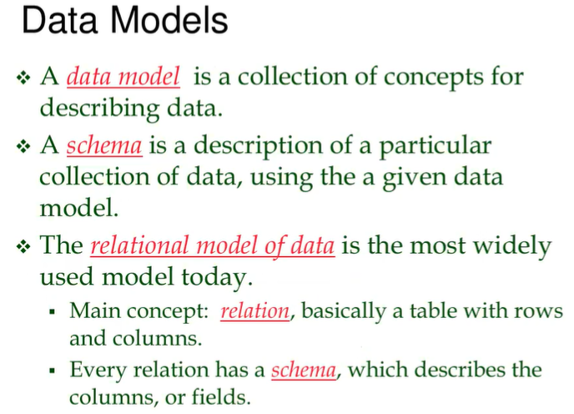
First we need to decide how to store our data. We need some guidelines that tells us how to structure our data, a “container” ⟹ data model
- In graph databases the data model are the graph, it tells us that all the data should be modeled as a graph

Data model
- Graph
- RDF
- Relational model (most used one)

Relation model is one of the first defined models, it is very simple and everybody can understand. The relations model tell us that if we want to store the data you do it by using one element ⟹ the relation. It is basically just a table (with subtle differences).

Every relation has a schema, which describes the columns or fields. A person to understand your data just needs to look at the name of the function and the parameters and some documentation that explain what the function does. To tell you how the data look like I do not have to tell you the content, I just have to tell you the name of the table, the column and the type of each column (string, boolean, …)
Schema = table type + columns + type of columns

Note: sometimes the columns are called fields or attributes

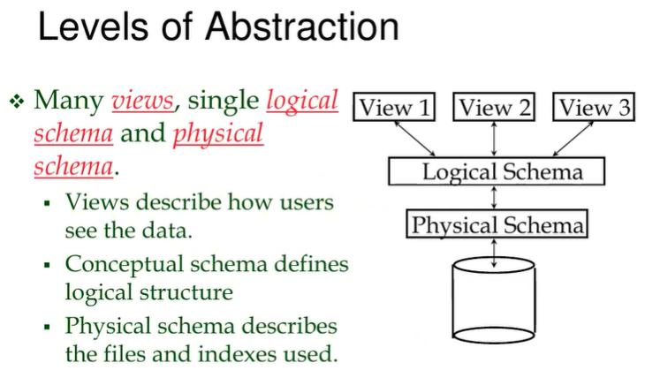
DBSM gives you some level of abstraction.
Logical schema: schema that we get from the relational model (all the tables are here)
Physical schema: not designed by the user ⟹ some guidelines of the system on how data should be organized (can be partially controlled by the user)

No matter if the logical schema changes, the schema will not change.

Levels of Abstraction in DBMS:
- Physical Schema: This is the lowest level of data abstraction. It describes how data is actually stored on the storage media such as hard disks. This includes details about the file formats, indexes for speeding up data retrieval, and data compression methods, among others. The physical schema is about the efficiency of storing and retrieving data and is managed by the DBMS. Users typically do not interact with this level directly.
- Logical Schema: This is the middle level of data abstraction that describes what data is stored in the database and the relationships among those data. In a relational database, this would be the collection of tables, their columns, and the relationships (like foreign keys) that link these tables. The logical schema is designed by the database designer based on the data requirements of the business or application.
- Views: These are the highest level of abstraction. A view is a subset of the database that is visible to a user. Views can be used to provide a specific user with access to certain data in a way that is most relevant to them, potentially across different tables, while hiding other data for security or simplicity.

Example:
Imagine a library database. The physical schema would be how the books' information is stored on the servers—like whether the data is in flat files, which indexing technique is used, etc.
The logical schema would be the design of tables such as Books, Authors, Categories, etc. It would define fields such as BookID, Title, AuthorID, CategoryID, and the relationships between these tables (e.g., each book is linked to a specific author).
Views might be created for different types of users:
- A view for the librarians might show extensive details about each book, such as the current borrower, due dates, and shelf location.
- A view for the borrower might show available books, due dates for borrowed books, and recommendations.

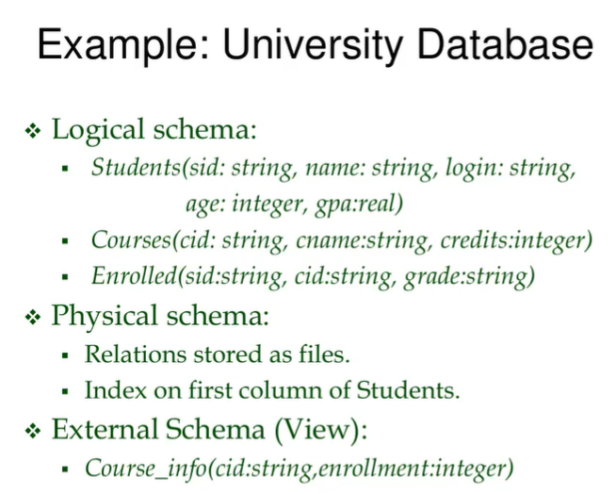
Student table with 5 columns
- Id ⟹ string
- name ⟹ string
- …

Note: never use the age of a person, use birthday because age changes every year

Enrolled table have 3 columns
- Id of a student
- Id of a course
- The mark

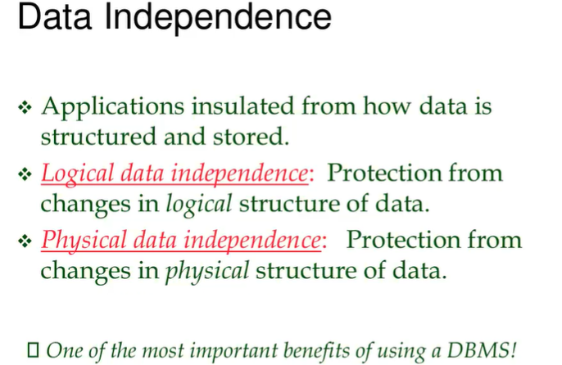

If we use the logical we get independence.


- Efficiency: different processes what to access the data ⟹ it split to give access to everybody

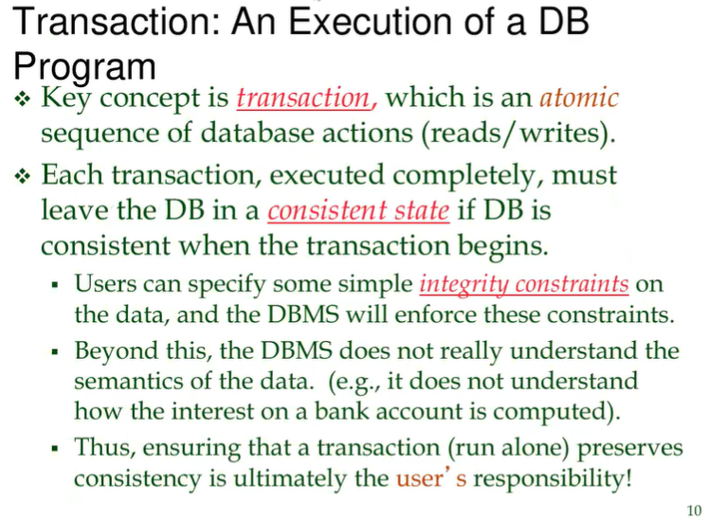
Atomic: sequence of actions, that must be executed all or nothing. Can not stop in the middle.

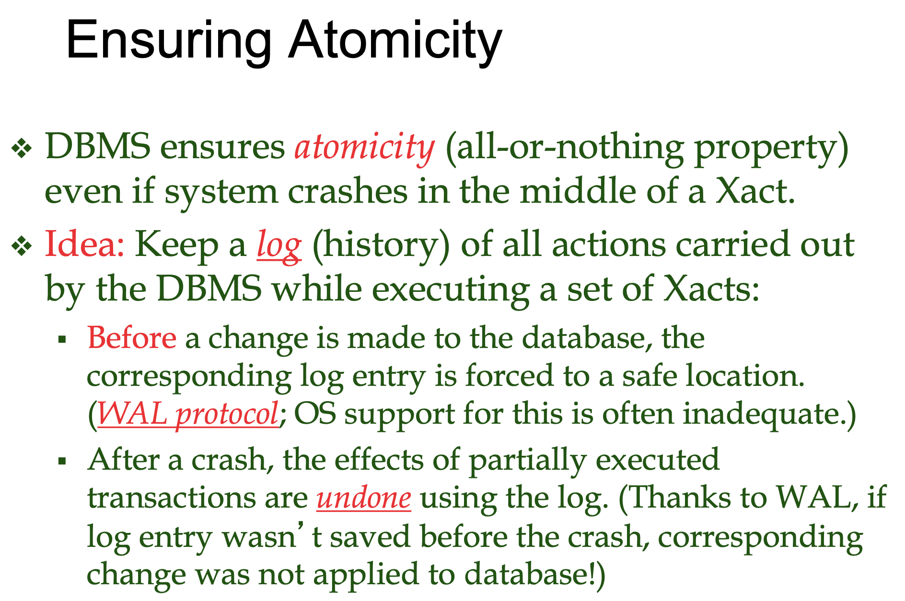

Whenever a translation is executed before executing the next action the DBMS logs in a file the step done before it applies the change. WAL protocol (Write Ahead Log), write what I am doing before I do it.

So if the system crash when is back working it goes first in the log, check which is the last action written and than it checks if that action was completed or not
- If it was completed fine
- Otherwise do it

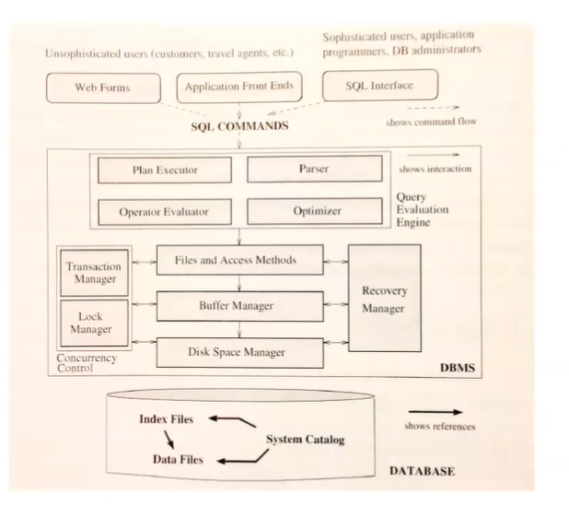

We will use an already established system, we will design a database. You design the program.

SQL is for querying, modifying data, …

In the bottom part of the image there is the database. You use SQL to get the data you want from the database. You don’t tell how to search the data, you tell just what to search. In python you tell how to do it, SQL is declarative instead.

